Throwing Velocity Camp
Get Faster Throws and Decrease Your Risk of Injury
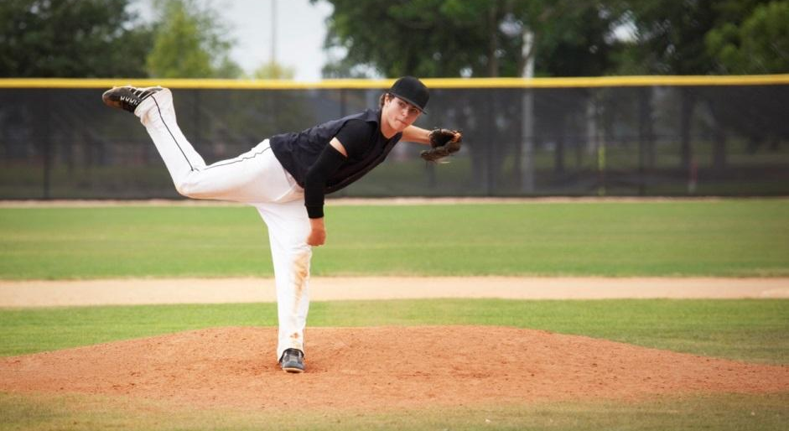
One of the five tools of a great baseball player is throwing ability. Division I college baseball coaches will be looking for players whose throwing abilities are at least 85 MPH, whether they’re throwing from the infield, outfield or the mound. Division II coaches will expect 82 MPH and above, and Division III requires speeds from the upper 70s.
What are you doing to enhance your throwing abilities and strengthen your rotator cuff?
(COMPANY NAME)’s Throwing Velocity program is guaranteed to increase velocity and decrease risk of injury. Athletes will focus on developing rotary propulsive power and building strength and stability in the muscles of the rotator cuff. (INSERT TESTIMONIAL / RESULTS IF YOU HAVE THEM)
(COMPANY NAME)’s Strength and Conditioning coaches (ADD YOUR COACHES’ CREDENTIALS HERE). Spots are limited – call (PHONE NUMBER) or log into your account to register!

(OPTIONAL: INSERT YOUR LOGO HERE)
Throwing Velocity Camp Details:
- (START DATE) through (END DATE)
- (DAYS OF WEEK), (START TIME TO END TIME)
- $(PRICE)/athlete - that’s just $(PRICE)/session)
Log in to your account at (WEB SITE ADDRESS) to enroll,
or call us at (513) 600-1519.
(ADD YOUR COMPANY NAME and SLOGAN HERE)
(STREET ADDRESS)

